Commercial Flight control

In order to test the construction of the XCopter for the first time,

without wasting too much time on developing an own flight control.

We decided to install a commercial flight control. In this case the DJI NAZA V2 was used.

It is a fully developed flight control unit, which was developed to be easily installed in any multi copter system. It comes with an integrated 3-axis gyro sensor and acceleration sensor as well as an external GPS unit. The only items which need to be connected to it are all Electronic speed controllers (ESCs) and a RC-receiver, the gimbal(DJI camera) part is not necessary.

If every Electronic Part is connected properly, the flight controller has to be configured by following these Septs:

1. Download the driver and the Assistant installation software in EXE format from www.dji.com.
2. Switch on the transmitter and then power on your autopilot system.
3. Connect your autopilot system and PC via a Micro-USB cable (according to image 1).

Required connections for USB:

* NAZA V2 Power Management Unit at **Exp.**
* V-Sen wire from PMU at **X3**
* USB adapter at **LED**

1. Open the driver installation software and follow the instructions to complete installation.

Important: The NAZA V2 has to be connected to install this driver

1. Run the Assistant installation software and follow the instructions to complete installation.
2. Select the “Basic” option. Please follow step-by-step for your first-time-configuration. Basic configuration is necessary, including Mixer Type, Mounting, RC, and Gain settings.

Further information can be found in the Help text of the NAZA V2 Assistant Software.

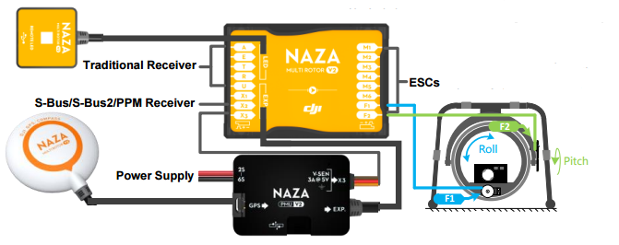

Screenshot from the DJI NAZA V2 quickstart guide.